Mastermind jr.

Project1

CSC- 5 – 46091 Intro C++

Jonathan Balisky

21 – July – 2015

Content

1.Introduction………………………………………….3-4  
Rule and Gameplay  
Thoughts after Program

2. Development………………………..………………4-5  
Approach Strategy

3. Research…………………………………………..…..5

Arrays

Parallel array

4. Variables list…………………………….………….…6

5. Topic Covered (Checklist)……………………………7

6. Libraries included……………………………………..7

7. Flowchart

8. Code

1. Introduction

**Rules and Gameplay**

This mastermind jr. is a simpler version of the original mastermind aimed at younger children. The original mastermind starts by randomly generating four different colors in a row. Then without showing it to the player the player has to find out that pattern of colors with a certain amount of guesses. Each time after the player guesses, it will tell the player how many colors are correct and are at the right place, and how many colors are the right colors but not in the right place. Due to my simple knowledge of c++ of change the colors to numbers (0-9). The program will generate 3 random numbers and the player has 9 chances to guess to number. If the player fails to guess the right number in 9 tries, the program will end and ask the player if they would like to try again.

**Thoughts after Program**

If I would to do this game again I would certainly like a graphical interface. For me much of the involvement in games comes due not only to mental stimulation but also visual stimulation.

The next step would be to use colors instead of numbers and have the screen populate with the guessed after each guess. If might also be nice to some type of animation if the player wins or loses. I also realize that I do not display the correct answer after the player losses. This can create some frustration for the player and should be corrected in the next version

2. Development

Approach Strategy

When searching for a project I wanted something fairly simply but still fun to play. That’s why I came up with mastermind jr. it’s still requires significant logic but even and simpleton like me can play.

There were several key elements that I needed for this project. First was the srand function. If the game had the same problem each time, it’s quite clear that not only would the game be very easy it also would be boring. Using this srand function mod 10 allowed me to create a random problem for the user to solve each time. Next huge need was arrays. Using arrays allowed me to do two things. First to be able input a number in which each character or integer is stored in its own separate “box”. This allowed me to then be able to check compare two arrays, or the user guess vs the answer, “box” by “box”. Without this there would be many more lines of code…which would be against “Marks law”. The last main component was the “for” loops. The “for” loops where essential, using such simple logic such as i = 0, if i<3, go ahead and do what comes next, and after your done add one to i. Combining this with arrays and the random function allowed me easy access to the answers. With the arrays and “for” loop I was able to create the bulk of the logic in this game.

3. Research

1. Arrays  
   This is best option to compare each digit of the answer each time the player enters their guess. It was possible to use if and else-ifs to do this, but it would require much more lines of code aka a waste of time and space. This also allow me to later expand the game without too much difficulty.
2. Parallel arrays  
   In this project because I used arrays I then could use parallel arrays. I needed parallel arrays to check in a particular location (answer[0] compare to usrG[0]), was the same or not. Then after comparing on location I could then loop the next (answer[0] compare to usrG[1]).
3. Ascii to integer  
   For ease of input I used a string as the user’s guess. Because string is stored as a character and an asci character cannot be compared directly to and integer there needed to be some type of conversion. Using a little concept that I found in my homework with a “for” loop and an array simply subtract 48 from each value and it can be compared to an integer
4. String.length

Because you can never be sure what the user might input I needed some type of check for the user’s guess. String.length was used check the length of the digits entered so if the user entered the wrong amount of digits I could loop and ask then to try again.

4. Variables list

|  |  |  |  |
| --- | --- | --- | --- |
| **Type** | **Variable Name** | **Description** | **Line** |
| int | count |  | 31 |
|  | realO[4] | the generated number save | 32 |
|  | real[4] | the generated number compare to guess | 33 |
|  | X | right place counter | 35 |
|  | O | right number counter | 35 |
|  | garr[4] | guess array after check validation | 159 |
| char | choice | choose which level | 29 |
|  | display | choose whether display the correct number or not | 30, 145 |
| string | sg | guess number input to check validation | 157 |
| bool | repeat | check whether generated digits are the same | 34 |
|  | valid | check sg validation | 158 |
|  | same[4] | to remember the place when the digit is at the right and avoid to count with int O | 160 |
| time_t | tstart | record start time | 230 |
|  | tend | record end time | 230 |
| ofstream | output |  | 36 |

5. Topic Covered (Checklist)

|  |  |  |  |
| --- | --- | --- | --- |
| Chapter | type | code | line |
| 2.1 Variables | int | int xs | 37 |
| 2.2 Input Output | Getline | Getlinw(cin,useG) | 75 |
|  | cout | cout<<"Input your guess: "<<endl; | 74 |
|  | endl | cout<<endl; | 55 |
| 2.3 data types | Short | Short ox | 38 |
|  | bool | bool repeat = false; | 34 |
|  | string | string sg; | 157 |
| 2.4 condition | = | Int i=0 | 62 |
|  | == | while(isvalid(usrG) == false); | 78 |
|  | ++ | i++; | 62 |
| 2.5 style | comment | //variables | 29 |
| 3.1 boolean expression | != | if(usrG.length() != 3){ | 139 |
|  | <, >, || | if (usrG[i] <48 || usrG[i] > 57){ | 145 |
| 3.2 multiway branches | if | if(usrG.length() != 3){ | 139 |
|  | else | else{ | 52 |
|  | nested | do{ | 42 |
|  |  | if(input.is_open()){ | 45 |
|  |  | for (int i = 0; i<11; i++){ | 46 |
| 3.3 type of loop | for | for(int i=0;i<11;i++){ | 46 |
|  | do-while | do{ }while(usrG[0]=='Y' ); | 45,103 |
| 4.2 predefined function | srand, time | srand(time(0)); | 41 |
|  | rand | answer[i] = rand()%10; | 121 |
| 4.3function prototypes | Int | int compare(int [], short&, string, bool[]); | 21 |
|  | Bool | bool isvalid(string); | 20 |
| 5.1 void function | void | void prepare(int [], int&, short&, int&, bool[]); | 19 |
| 5.2 call-by-reference | & | int compare(int [], short&, string, bool[]); | 21 |
| 6.1 streams and basic | ofsream declare | ofstream output; | 34 |
|  | Ifstream declare | Ifstream input | 35 |
|  | Input | input.open("instructions.txt"); | 44 |
|  | Input.close | input.close(); | 50 |
|  | output | output.open("Answer.txt"); | 60 |
|  | close | output.close(); | 65 |
| 7.1 array | int array | Int answer[SIZE] | 31 |
|  | bool aray | Bool mathc[SIZE] | 32 |

6. Libraries included

* <cstdlib>
* <iostream>
* <ctime>
* <fstream>

7. Pseudo code

Set time seed

Output instruction from file

Do

Call prepare function

Random answer and initialize other variables

Output the answer to file

Game start

do

Input guess number

Call isvalid to check validation

Call compare function

Display Xs and Ox (result)

Guess -1

While guess>0 and guess answer is not correct

If x==3 output win

Else output lose

Ask for another new game

While(Yes)

7. Flowchart

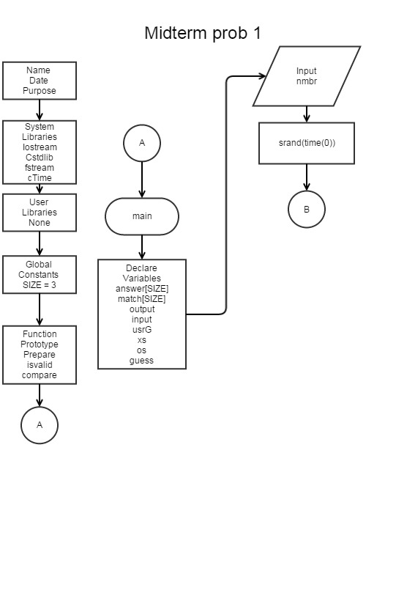

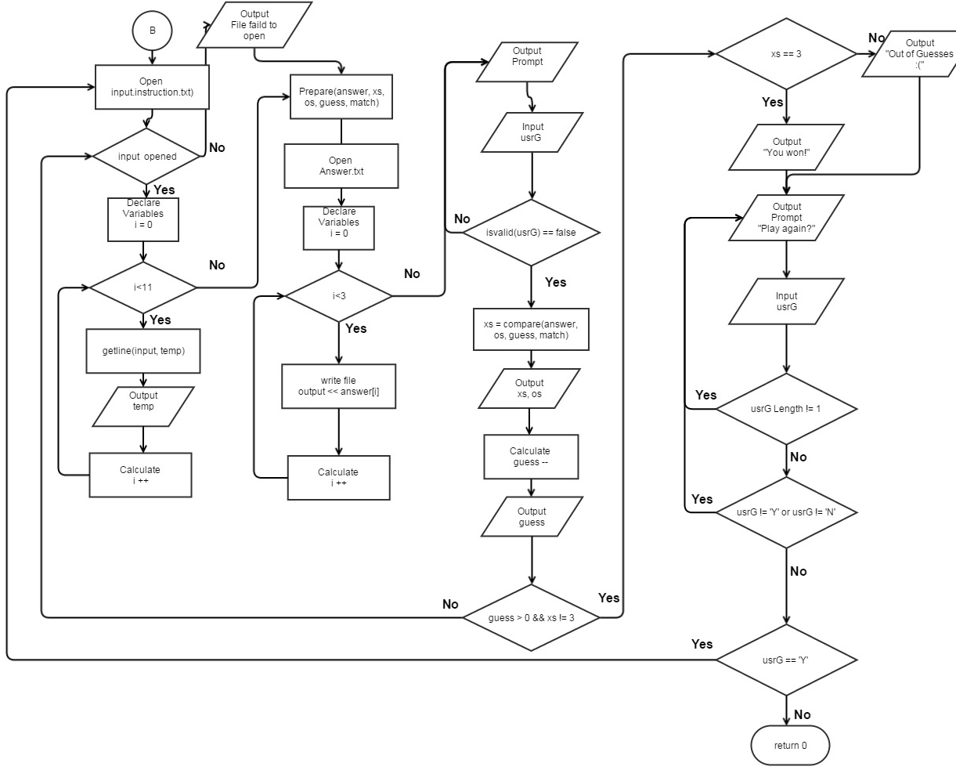

Prepare

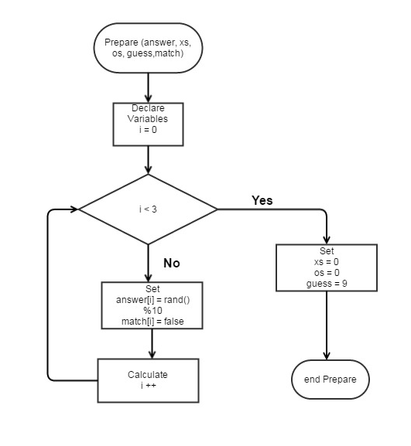

isValid

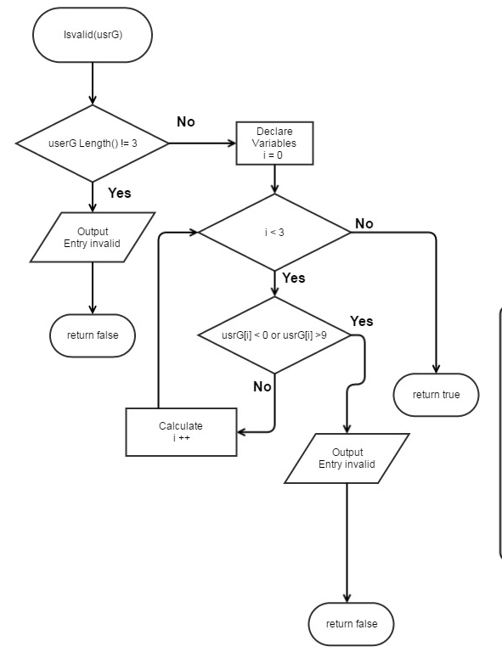

isValid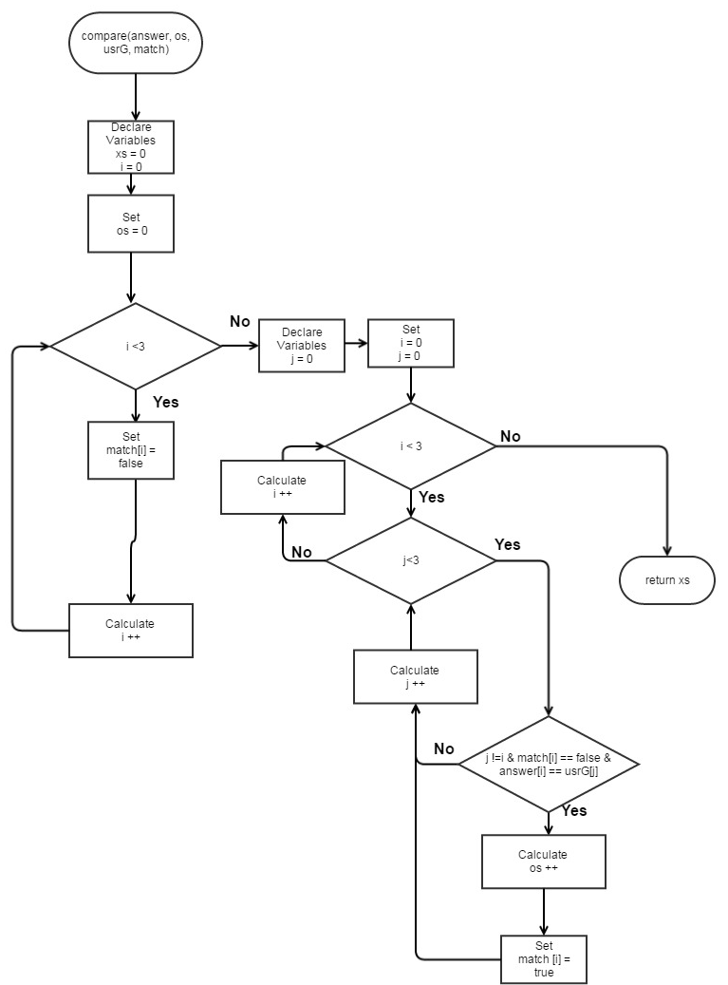

8. Code

/*

File: Project 1.cpp

Author: Jonathan Balisky

Created on July 19, 2015, 9:18 pM

Purpose: Mastermind jr.

*/

//Libraries

#include <iostream>

#include <string>

#include <cstdlib>

#include <fstream>

#include <ctime>

using namespace std;

void prepare(int [], int&, short&, int&, bool[]);

bool isvalid(string);

int compare(int [], short&, string, bool[]);

//Global

const int SIZE = 3;

int main(int argc, char** argv) {

//Variables

int answer[SIZE]; //number of pin

bool match[SIZE]; //Which numbers are matched

string temp; //For the file output

ofstream output; //

ifstream input; //inputting to the file

string usrG; //The users guess or input

int xs; //How many x's

short os; //How many o'x

int guess; //How many guess the user had guessed

srand(time(0)); //setting time seed

do{

// cout<<"Call prepare."<<endl;//For diagonostics

input.open("instructions.txt");

if(input.is_open()){

for (int i = 0; i<11; i++){

getline(input,temp);

cout<<temp;

}

input.close();

}

else{

cout<<"Instructions failed to open"<<endl;

}

cout<<endl;

prepare(answer, xs, os, guess, match); //Initialize

// cout<<"Call prepare."<<endl;//For diagonostics

output.open("Answer.txt");

for (int i = 0; i<3; i++){

output<<answer[i];

}

output.close();

// for(int i=0;i<3;i++){

//cout<<answer[i]; //For diagonostics

// }

do{

do {

cout<<"Input your guess: "<<endl; //User enter guess

getline(cin,usrG);

//cin.ignore();

}while(isvalid(usrG) == false); //Loop until user enters valid answer

xs=compare(answer, os, usrG, match);

cout<<"x="<<xs<<endl; //Right numbers in right space

cout<<"o="<<os<<endl; //How many Correct number but in the incorrect space

guess--;

cout<<"Guesses left: "<<guess<<endl;

}while(guess > 0 && xs != 3);// User out of guess or has guess correctly

if ( xs == 3){ //user won

cout<<"Congrats you won!"<<endl;

}

else{ //user lost

cout<<"Sorry but you ran out of guesses. :( "<<endl;

}

do{ //Checking for an input of Y or N

do{ //Checking for input over 1 char

cout<<"Play again Y/N?"<<endl;

getline(cin,usrG);

}while(usrG.length() != 1);

}while(usrG[0]!=89 && usrG[0]!=78);

//}while(usrG[0] > 'Y' || usrG < 'N' || (usrG[0]>'N' && usrG[0]<'Y'));

}while(usrG[0]=='Y' );

cout<<"See you again next time!"<<endl;

return 0;

}

/***************************************Prepare**************************************************

* Purpose: Initializing values for the game.

* Input: answer, xs, os, guess, match

* Output:

* none

***********************************************************************************************/

void prepare (int answer[], int &xs, short &os, int &guess, bool match[]){

for (int i = 0; i<3; i++){

answer[i] = rand()%10; //creating answer from 0-9

match[i] = false; //Set all to false

//cout<<"answer = "<<answer[i]; //For diagonostics

}

// cout<<endl;

xs = 0;

os = 0;

guess = 9;

}

/***************************************isvalid**************************************************

* Purpose: To check whether or not the user entered 3 numbers

* Input: usrG

* Output: True or false

***********************************************************************************************/

bool isvalid(string usrG){

// cout<<"Call isvalid."<<endl; //For diagonostics

if(usrG.length() != 3){

cout<<"Please enter THREE numbers"<<endl;

return false;

}

else{

for(int i = 0; i < 3; i++){

if (usrG[i] <48 || usrG[i] > 57){

cout<<"Number not entered"<<endl;

return false;

}

}

// cout<<"number valid"<<endl;//For diagonostics

return true;

}

}

/***************************************Compare**************************************************

* Purpose: To compare the user's guess with the answer and return how many

* were correct or incorrect.

* Input: answer, os, usrG, match

* Output:xs

***********************************************************************************************/

int compare(int answer[], short &os, string usrG, bool match[]){

int xs = 0;

os = 0;

for(int i = 0; i<3; i++){

match[i] = false; //int all values to zero again

}

//Checking for correct position

for(int i = 0; i<3; i++){

if(answer[i] == (usrG[i]-48)){

xs++;

match[i] = true;

}

}

//Checking for os

for(int i = 0; i<3; i++){ //i is position of answer

for(int j = 0; j<3; j++){ //j is position of usrG(user guess)

if(j !=i && match[i] == false && answer[i] == usrG[j]-48){

//cout<<"increased o"<<endl; //For diagonostics

os++;

match[i] = true;

}

}

}

return xs;

}